**16.** **mailregisterapp**

**Step-1:Created a react app with name mailregisterapp**

**>npx create-react-app mailregisterapp**

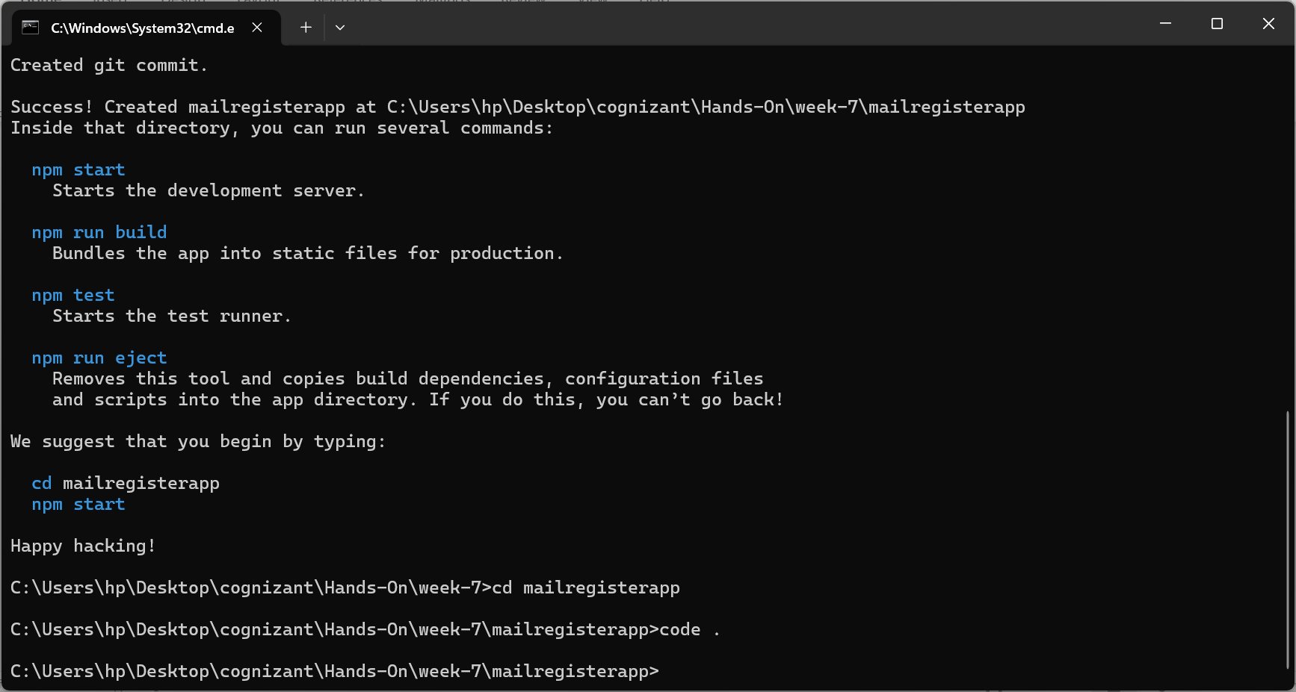

**Step-2:**

**Created a class component Register which uses eventhandlers like HanldeChange(), HandleSubmit()**

**Step-3;** Created 3 if conditions for checking **length of name, does email contain ‘@’ and ‘.’ , password length >8**

**Register.js**

import React, { Component } from 'react';

export class Register extends Component {

  constructor() {

    super();

    this.state = {

      name: '',

      email: '',

      password: '',

      errors: {}

    };

    this.handleChange = this.handleChange.bind(this);

    this.handleSubmit = this.handleSubmit.bind(this);

  }

  //Called on every input change

  handleChange(event) {

    this.setState({ [event.target.name]: event.target.value });

  }

  // Called on form submit

  handleSubmit(event) {

    event.preventDefault();

    const { name, email, password } = this.state;

    let errors = {};

    if (name.trim().length < 5) {

      errors.name = "Name should be at least 5 characters long.";

      alert(errors.name);

    }

    if (!email.includes('@') || !email.includes('.')) {

      errors.email = "Email should contain '@' and '.'.";

      alert(errors.email);

    }

    if (password.length < 8) {

      errors.password = "Password should be at least 8 characters.";

      alert(errors.password);

    }

    //any errors, update state

    if (Object.keys(errors).length > 0) {

      this.setState({ errors });

    } else {

      alert("Form submitted successfully!");

      this.setState({

        name: '',

        email: '',

        password: '',

        errors: {}

      });

    }

  }

  render() {

    const { name, email, password } = this.state;

    return (

      <div style={{ width: "400px", margin: "20px auto"}}>

        <h1 style={{color : "red"}}>Register Here!!!</h1>

        <form onSubmit={this.handleSubmit}>

          <label>Name:</label>

          <input name="name" value={name} onChange={this.handleChange}/>

          <br />

          <label>Email:</label>

          <input name="email" value={email} onChange={this.handleChange}/>

          <br />

          <label>Password:</label>

          <input name="password" type="password" value={password} onChange={this.handleChange}/>

           <br />

          <button type="submit">Submit</button>

        </form>

      </div>

    );

  }

}

**App.js**

import React from 'react';

import { Register } from './Register.js';

function App() {

  return (

    <div>

      <Register />

    </div>

  );

}

export default App;

**Step-4:**

**Output:**

